
Programming Language For
Business Analytics

Assisgnment No 2

Submitted To:
Ms. Sameet Fatima
Submitted By:
Muhammad Ahmed (FA24-BBA-032)

Date: 17 October 2025
Task 1:
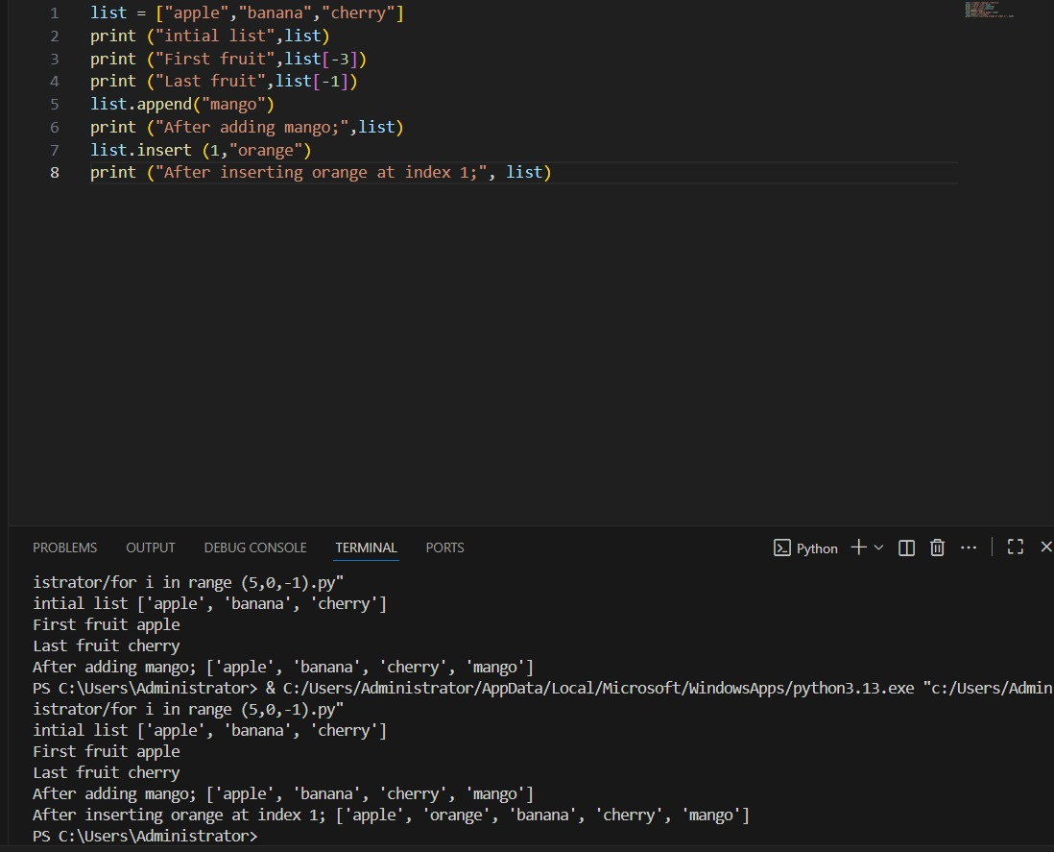
Task 2:
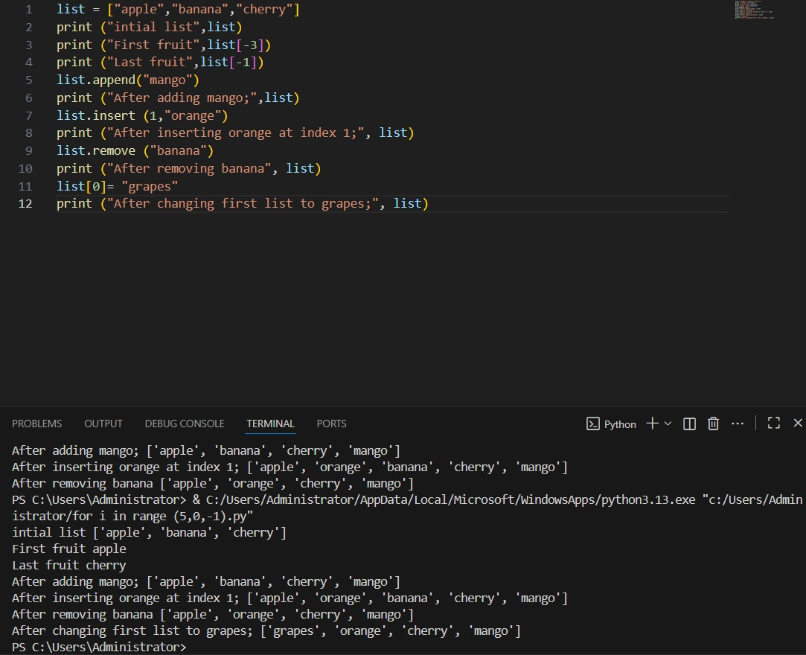

Task 3:
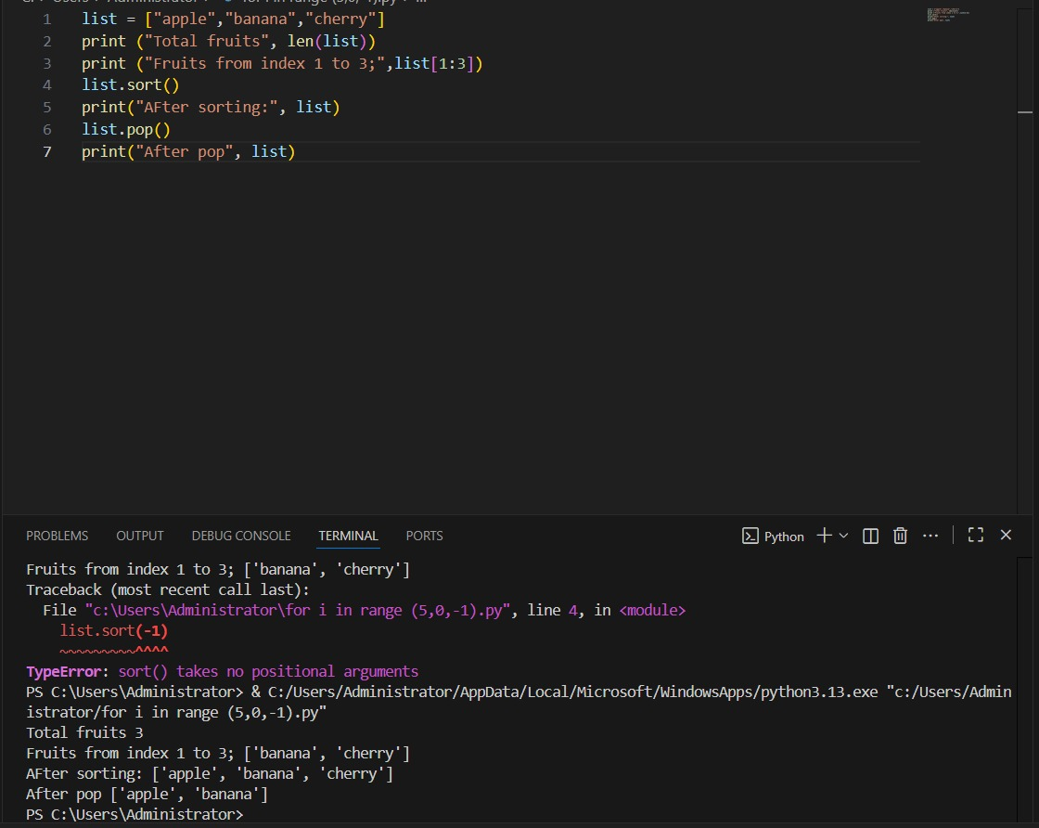

Task 4:
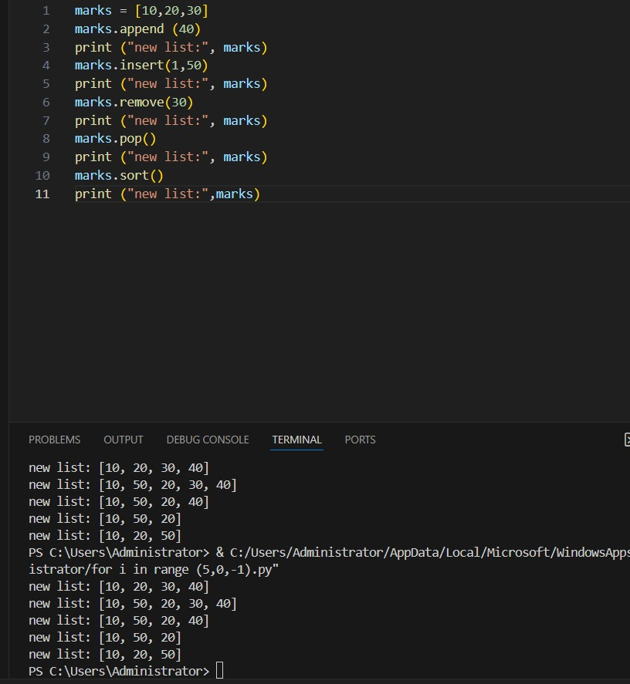
Task 5:
